Abstract—The paper presents a portable fiber – optic current sensor (FOCS), modified for current harmonic measurement in high voltage electric power systems. The details of the sensing head redesign are illustrated. Also, both electronic processing block and harmonic analysis algorithm have been illustrated. The practical application of the so - redesigned device has been successfully verified experimentally for a thermal power plant. The measurements have been made for the operation of 6 kV induction motor with different load conditions and thyristor excitation of 15 kV a.c. generator. The experimentally determined current waveforms, the corresponding relative harmonics content computed by discrete Fourier transform and total harmonic current distortion for various measuring points have been displayed. The important requirements for accurate harmonic measurements have been discussed. The results clearly verified the applicability of FOCS suggested in this paper, for monitoring electric power quality.
Practical Application of Fiber Optic Current Sensor in Power System Harmonics Measurement
Slobodan J. Petricevic, Zlatan Stojkovic, Jovan B. Radunovic
Index Terms—Fiber-optic current sensor (FOCS), harmonics, measurement, monitoring, electric power quality

Introduction
Power system planning, design and operation require careful analysis and measurements in order to evaluate the overall performance, safety, efficiency, reliability and economics. The modern technology implementation, the needs of utility business practice and consumer demand under deregulation rules are the most important challenges for power system engineers.
The estimation of the harmonic levels in electric power systems has a great significance for a proper evaluation of electric power quality. The harmonic sources detection, performing the harmonic analysis and the explanation of the results represent typical steps in this procedure. The main harmonic sources in the power system have been systematized in [1]. The use of nonlinear loads connected to electric power systems changes the sinusoidal nature of the a.c. current thereby resulting in the flow of harmonic currents in the a.c. power systems, that can cause interference with communications circuits and other types of equipment.
There are several approaches for the harmonic analysis. The classical approach includes theoretical analysis, forming the mathematical model of the system and performing the computer simulation [2]. Inquiry and statistical elaboration represent the other approaches for the harmonic analysis [3]. The third step in the harmonic analysis is the comparison of the results with recommended current harmonic limits, defined in [4,5].
Performing harmonic measurements is an important part of many harmonic investigations. For some situations, it may be possible to accomplish all of the objectives with simulations. However, measurements will often be needed for any of the following reasons:
• To characterize existing background harmonic levels, including statistical characteristics;
• To determine harmonic source characteristics;
• To validate simulation models.
Several advantages of FOCS have been recognized compared to conventional, iron-core current transformers. The immunity to electromagnetic interference, noncontact measurement, high dynamic range, compact design, impossibility of explosion, and high bandwidth that allows harmonic analysis of current represent the main advantages of FOCS from the electrical power industry aspect. The latest optical current sensing techniques are illustrated in [6]-[13].
The practical application of FOCS in high voltage power system harmonic measurements is the main goal of this paper.
For this purpose, FOCS described in [13] has been substantially modified. The redesign of the sensing head enables the benefit of sheet firmness, thus minimizing mechanical effect on the sensing process. Also, the electronic processing block and harmonic analysis algorithm have been described in detail.
In order to determine the current harmonics content in real conditions, series of experiments have been made at the thermal power plant “Nikola Tesla”, Electric Power Industry of Serbia. For the operation of 6 kV induction motor with different load conditions and thyristor excitation of 15 kV a.c. generator the current harmonic measurements have been performed.
The current waveforms and the corresponding relative harmonics content for all denoted measuring points have been displayed. Also, the total harmonic current distortion at all measuring points is discussed. The results explicitly indicated that so-modified portable FOCS is suitable for current harmonic measurement, which might serve for monitoring electric power quality.

II Focs Design From Harmonic Analysis Point Of View

Existing FOCS Design
As reported in [13], portable FOCS is capable of harmonic analysis of the current. This design is built around open able magnetic ring core sensing head containing Faraday crystal (TGGG - Gadolinium Gallium Garnet doped with Terbium). Experiments demonstrated non-linear detection process nature visible at 1kA excitation. However, if lower currents are being tested to harmonics content, theoretical analysis predicts higher linearity of the detection process and possible use of the sensing head without later correction of the intrinsic non linearity. In order to obtain accurate harmonic image of the current, in addition to compensation of the detection process nature, one must also verify electronic detector circuit to frequency bandwidth and possible nonuniformity in frequency response due to mechanical construction of the sensing head.

Modifications
The most important modification involves the design of the advanced sensing head seen in Fig. 1. Redesigned model is smaller, lighter, much more rigid and entire ring is covered in plastic coating. This provides the benefit of sheet firmness, thus minimizing mechanical effects on the sensing process.

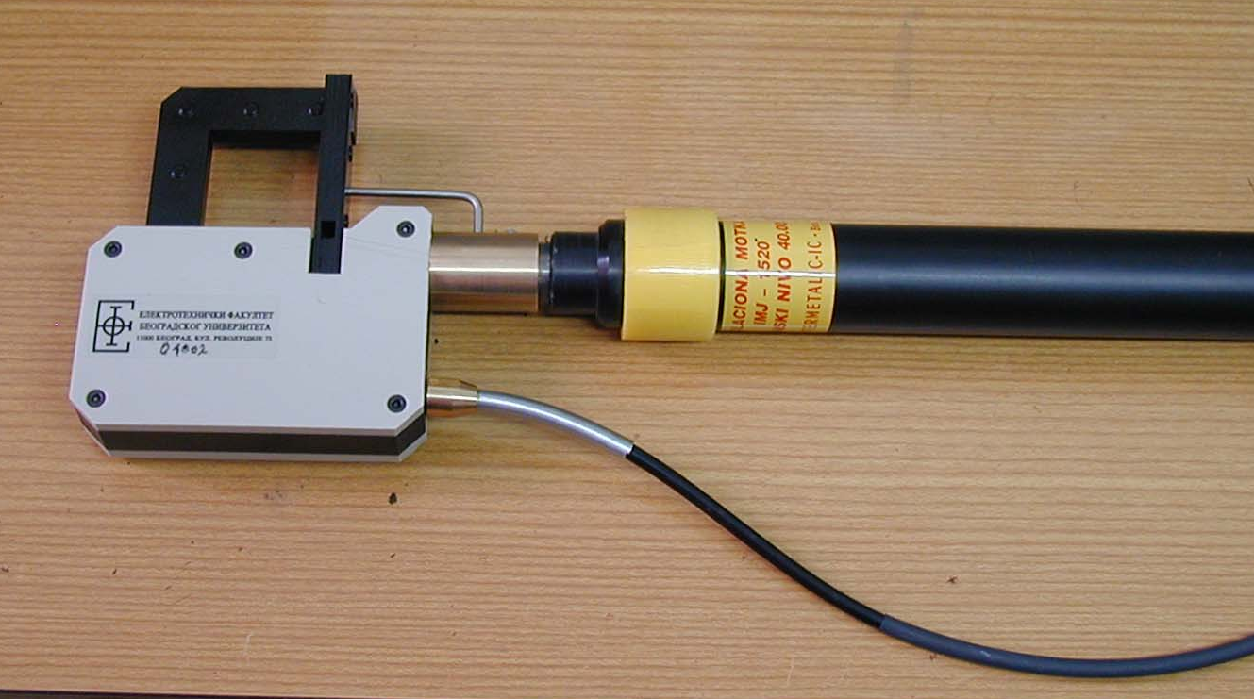

Fig. 1 FOCS sensing head mounted on an isolation stick
Since sensing head is made from laminated metal sheets, one can expect to see some frequency dependence of the transfer function due to resonance effects between sheet structure and magnetic field. This could lead to potential nonuniformity of the frequency transfer function. In order to verify this, 20 windings have been wound around one side of the sensing head and 5 A rms test current of desired frequency passed from generator as seen in Fig. 2. Test current was monitored on the shunt resistor using oscilloscope and results were taken using calibrated FOCS detector circuit. Nonuniformity in amplitude response at frequency f (A(f)) relative to response at 50 Hz (A(50 Hz)) is shown in Fig.3.
Plastic coating is used to good effect in equalizing amplitude response, and additionally prevents head heating due to Fuke currents. Absolute error remains within 1% of the nominal response at 50 Hz. This type of error can also be compensated using calibration table obtained by calibrating each sensing head in his way.

Fig. 2 Sensing head amplitude response test setup
Fig. 3 FOCS sensing head relative amplitude response in terms of frequency

Electronic Processing Block
FOCS described in [13] already contains all the necessary electronic components to properly calculate current harmonics content. Photodetector transimpedance stage (TIA) built around a phototransistor is followed by an AC coupled amplifier (x10) and both DC and AC component of the light are passed on to a high resolution ΣΔ AD converter (PCM1800). Microcontroller (μC) controls AD converter and collects data from both channels into memory (SRAM). Results are presented on a graphic LCD or transferred to a PC using RS-232 link. Complete electronic processing block is presented in Fig. 4.
Tracing 20th harmonic requires 1 kHz bandwidth. AD samples at 28800 Hz thus satisfying Nyquist criterion. As noted in [13] DC light component is used to divide the AC signal component (containing harmonics) in order to eliminate light intensity variations.
Fig. 4 Electronic processing block

μC

SRAM

LCD
RS-232

LED
Photo
transistor
Fibers to and from sensing head
TIA
x10

PCM1800
2
1
LAPTOP

In order to determine frequency bandwidth of the detector circuit, it has been exited with a sinusoidally modulated light of known frequency from a red LED (Infineon SFH756V) and amplitude response using oscilloscope has been measured. Result is shown in Fig. 5. Single -3dB pole resides at 750 Hz, a contribution from low frequency phototransistor in transimpedance detector stage. In order to obtain accurate harmonic image, compensation of this effect must be performed. This can easily be done with calibration table in microcontroller memory with entries for each harmonic frequency of interest.
Fig. 5 Detector circuit amplitude response as a function of frequency

Harmonic Analysis Algorithm
FOCS provides digitized current waveform in time domain. From this time series, harmonics content is obtained by Fourier transform. Sampling frequency is set at 28800 Hz, with 576 points inside one 50 Hz period. Let us denote sampling frequency with f_{S} and number of points (length) inside time series with N. Resolution in frequency domain (size of bin) equals:
$Δf=\frac{f_{S}}{N}$ ( )
This is the key factor in harmonic analysis. Lowering Δf improves resolution of the harmonic image as seen in Fig. 10, Fig. 12, Fig. 14 and Fig. 16 but requires larger N (longer time series) and stronger computation power, which is typically not available in a microcontroller based system such as FOCS. In order to verify this, the current waveforms from FOCS memory have been transferred to a PC. Further, by applying discrete Fourier transform the relative current harmonics content has been computed.

Time series contained N=9216 points resulting in Δf=3.125 Hz. This resolution is good enough to sense harmonic location in spite of spectrum leakage effect caused by AD converter sampling rate not being frequency locked to sensed current frequency which deviates somewhat from 50 Hz. Discrete shape of these spectra suggests strong energy concentration at harmonic frequency and very little distribution around it originating from leakage. Space between harmonics contains only noise. This in fact means that higher Δf that would include energy around exact harmonic frequency would still provide accurate result. If Δf is set to 50 Hz for a single FFT bin to include entire frequency range from harmonic to harmonic, then computational power required to produce spectra would be lowered to a level acceptable for a microcontroller based sensing system. Entire harmonics range of interest (about 1 kHz) could then be covered with 32 points in frequency domain, with each harmonic energy placed inside one frequency bin. This FFT has been coded successfully into microcontroller program memory and time required to compute FFT was found to be 5 seconds for an 8052 MCU running at 22 MHz. This is acceptable for field monitoring and would allow portable FOCS to be applied in harmonic analysis role without supporting PC (laptop). This is of course just an indicating instrument that could provide additional information on the current harmonics content in the field use for the purpose of monitoring electric power quality.

Experimental Investigation

Setup Description
In order to demonstrate the FOCS harmonic measurement possibilities, series of experiments were conducted at the thermal power plant “Nikola Tesla”. This plant is a part of Electric Power Industry of Serbia, and consists of six 15 kV generators with a total capacity of 1260 MW. A single-line diagram of the part of denoted plant, including only one generator (A2) is shown in Fig. 6.
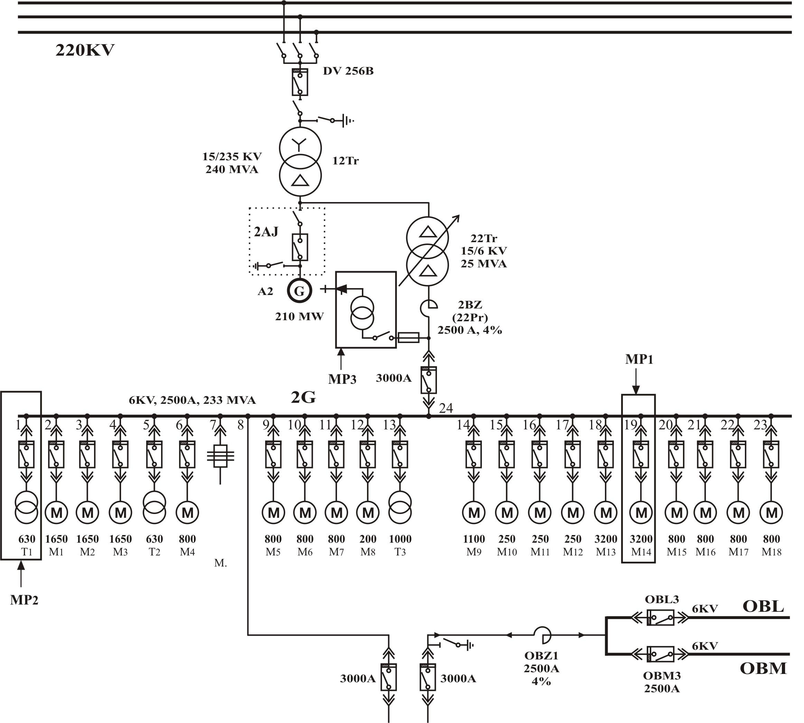
Fig. 6 A single-line diagram of the part of investigated plant

This generator is a 3-phase, a.c. synchronous generator with rated voltage 15 kV. The generator is connected to the low voltage side of one main three-winding transformer 15/235 kV with 240 MVA capacity. The high voltage side of main transformer is further connected to the corresponding bay of 220 kV switchgear.
The 6 kV switchgear is provided to be used for auxiliary power supply to plant. This switchgear is connected to the low voltage side of one auxiliary three-winding transformer 15/6 kV with 25 MVA capacity. The 6 kV switchgear load consists of several induction motors (M) and auxiliary transformers (T1-T3) loads, as denoted in Fig. 6. Also, a thyristor excitation of the A2 generator has been used.
Many others details of the electrical system of the analyzed plant are not presented, in order to make the experimental study easy to understand.
The operation of induction motor and the thyristor excitation represent the sources of harmonics. Three measuring points (MP1,MP2,MP3) are denoted in Fig. 6. The denotations have the following meanings:
MP1 – the measuring point for the unloaded (MP1a) and loaded (MP1b) pump of the A2 generator, respectively;
MP2 – the measuring point for the 630 kVA, 6.3/0.4 kV transformer of the A2 generator filter;
MP3 – the measuring point for the thyristor excitation of the A2 generator.

Fig.7 displays FOCS harmonic measurement setup photograph at the measuring point MP1. A transfer of results from FOCS to a lab top computer is illustrated in Fig. 8.

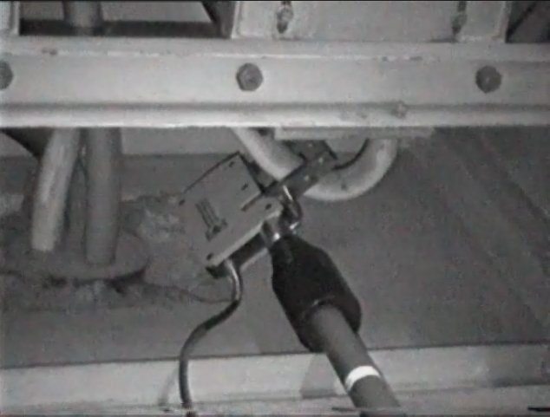
Fig. 7 FOCS harmonic measurement setup photograph

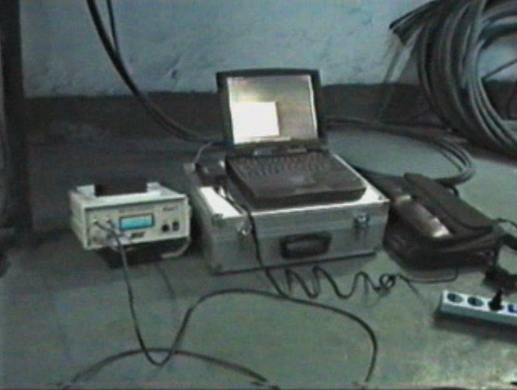

Fig. 8 Illustration of a transfer of results from FOCS to a lab top computer

Measurement Results
Using FOCS, the current waveforms at the all denoted measuring points have been registered. Fig. 9 displays the experimentally determined current waveform of the A2 generator unloaded pump. As mentioned previously, this measuring point is denoted as MP1a. From the result presented in Fig. 9 it can be concluded, that the distortion of current is obtained, which is a consequence of the unloaded regime of the pump.
The relative harmonics content of the current presented in Fig. 9 has been calculated and shown in Fig. 10. From Fig. 10 relative small presence of higher harmonics is notable. The amplitudes of the third and the fifth harmonics are below 1.5% and 4%, respectively.
The experimentally determined current waveform of the A2 generator loaded pump is presented in Fig.11. The load was near the nominal value. As a result of this regime, the current waveform practically doesn’t consist of the higher order harmonics. The corresponding relative harmonics content of this current, presented in Fig. 12, confirms this conclusion.
On the other hand, the current waveform, measured at MP2 indicates the appearance of higher harmonics (Fig.13). In this case, the transformer as ferromagnetic (nonlinear) device represents the harmonic source.
The corresponding relative harmonics content of this current is presented in Fig. 14. From Fig. 14 it is clearly shown, that the amplitudes of the third and the fifth harmonics are equal 20% and 17%, respectively, which is more much in comparison to the values from previous cases.
Thyristor, as power electronic type device is a strong source of current harmonics. The current waveform measured at MP3 clearly illustrates this fact (Fig. 15). The corresponding relative harmonics content of this current is presented in Fig. 16. From graph shown in Fig. 16, it can be pointed out that the fifth harmonic is dominant with maximum value of 20 %. The appearance of even harmonics in this case is a consequence of the asymmetrical (unbalanced) thyristor operation.
The experiments showed that FOCS satisfied all important requirements for accurate harmonic measurements in electric power systems.
As a summary of presented results, a total harmonic current distortion (THCD) at measuring points has been calculated (Fig. 17). The calculation of THCD has been performed according to the recommendation given in [4]. The THCD results from Fig. 17 clearly confirm the previous denoted conclusions. It can be pointed out that the THCD value for the most critical case (MP2) equals 29.26%, which is out of the recommended limits defined in [4].

Fig. 9. Current waveform of the A2 generator unloaded pump in time domain -measuring point MP1a

Fig. 10. Relative harmonics content of the current of the A2 generator unloaded pump in frequency domain -measuring point MP1a

Fig. 11. Current waveform of the A2 generator loaded pump in time domain -measuring point MP1b
Fig. 12. Relative harmonics content of the current of the A2 generator loaded pump in frequency domain -measuring point MP1b
Fig. 13. Current waveform of the 630 kVA 6.3/0.4 kV transformer of the A2 generator filter in time domain -measuring point MP2

Fig. 14. Relative harmonics content of the 630 kVA 6.3/0.4 kV transformer of the A2 generator filter in frequency domain - measuring point MP2

Fig. 15 Current waveform of the A2 generator thyristor excitation in time domain - measuring point MP3

Fig. 16. Relative harmonics content of the current of the A2 generator thyristor excitation in frequency domain - measuring point MP3
Fig. 17 THCD values at the measuring points

CONCLUSION

The proper measurement of the current harmonic levels is of great importance for an integral evaluation of the electric power quality. Having in mind several advantages of FOCS compared to conventional measuring devices, it had been continued in an effort to realistically achieve its application in this field. From this reason the presented FOCS based on the Faraday effect with magnetic concentrator was substantially redesigned. The so-formed device has been experimentally verified in real conditions, indicating its acceptable accuracy. Described device is portable and suitable for the current harmonic measurement in high voltage electric power systems.

AKNOWLEDGMENT

The authors would like to thank the Alexander von Humboldt Foundation, Bonn, FR Germany and the Ministry of Science, Development and Technology of the Republic of Serbia for supporting this work.
The authors express their sincere thanks to staff of the thermal power plant “Nikola Tesla”, for their cooperation in the experimental investigation.
REFERENCES

[1] R. Natarajan, “Computer-Aided Power System Analysis”, Marcel Dekker Inc., New York, NY, USA, 2002.
[2 ] J. Arrillaga, D. Bradley, P. Bodger, “Power System Harmonics”, John Wiley & Sons, Chichester, 1985.
[3] J. Milanovic, M. Negnevitsky, “Quality of Electricaly Supply in Tasmania: Problems reported by the Utility and Industry”, The Australian University Power Engineering Conference, Sydney, 1997., pp.361-364.
[4] IEEE Standard 519 : “IEEE Recommended Practices and Requirements for Harmonic Control in Electrical Power Systems”, IEEE, New York, 1992.
[5] IEC 1000-2-2 : “Electromagnetic compatibility (EMC) – Part 2: Environment – Section 2: Compatibility levels for low-frequency conducted disturbances and signalling in public low-voltage power supply systems”, International standard IEC, Geneve, 1990.
[6] G. Li, M. G. Kong, G. R. Jones, J. W. Spencer, "Sensitivity Improvement of an Optical Current Sensor with Enhanced Faraday Rotation," Journal of Lightwave Technology, Vol. 15, No. 12, December 1997, pp. 2246-2252.
[7] P. Niewczas, W. I. Madden, W. C. Michie, A. Cruden, J. R. McDonald, "Magnetic Crosstalk Compensation for an Optical Current Transducer," IEEE Transactions on Instrumentation and Measurement, Vol. 50, No. 5, October 2001, pp. 1071-1075.
[8] T. Wang, C. Luo, S. Zheng, "A Fiber-Optic Current Sensor Based on a Differentiating Sagnac Interferometer," IEEE Transactions on Instrumentation and Measurement, Vol. 50, No. 3, June 2001, pp. 705-708.
[9] J. D. P. Hrabliuk,"Interfacing Optical Current Sensors in a Substation," Power Engineering Society Summer Meeting, 2001, Vol. 1, 2001, pp. 147-155.
[10] K. Bohnert, P. Gabus, J. Nehring, H. Brändle, "Temperature and Vibration Insensitive Fiber-Optic Current Sensor," Journal of Lightwave Technology, Vol. 20, No. 2, February 2002, pp. 267-276.
[11] P. Perez-Millan, L. Martinez-Leon, A. Diez, J. L. Cruz, M. V. Andres, "A Fiber-Optic Current Sensor with Frequency-Codified Output for High-Voltage Systems," IEEE Photonics Technology Letters, Vol. 14, No. 9, Spetember 2002, pp. 1339-1341.
[12] A.E. Petersen, "Portable optical AC- and proposed DC-current sensor for high voltage applications," IEEE Transactions on Power Delivery, Vol. 10, No. 2, April 1995 pp. 595-599.
[13] P. Mihailovic, S. Petricevic, Z. Stojkovic, J. Radunovic, “Development of a Portable Fiber Optic Current Sensor for Power Systems Monitoring”, IEEE Transactions on Instrumentation and Measurement, Vol. 53, No. 1, February 2004., pp. 24-30.

The Biographies


Slobodan Petricevic was born in Osijek, Croatia, in 1971. He received his B.Sc. degree in 1996 and M.Sc. degree in 2001 from the Faculty of Electrical Engineering, University of Belgrade, Yugoslavia. Since 1996, he works as a design engineer specialized in instrumentation electronics and electrooptics.


Zlatan Stojkovic (1960) graduated in 1984, took his M.Sc. degree in 1991 and his Ph.D. degree in 1995 at the Faculty of Electrical Engineering in Belgrade / Yugoslavia. From 1984 to 1992 he was with Energoprojekt Hydroengineering Consulting Engineers, Belgrade, Yugoslavia, where he worked as a design engineer of the hydropower plants. Since 1993 he is with the Faculty of Electrical Engineering, University of Belgrade. He is at present associate professor teaching computer-aided design in power systems and high voltage technique.
Under a scholarship granted by the Alexander von Humboldt Foundation, Bonn, Germany, he was in 1997/98 a Postdoctoral Fellow at the Institute of Electric Energy Systems and High Voltage Technology, University of Karlsruhe, Germany. As the Humboldt Fellow, he is at present with the Institute quoted, performing special program within the framework of the Stability Pact for South-eastern Europe.
Dr. Stojkovic received five awards for the best scientific papers in the national CIGRE Group 33 – Overvoltages and Insulation Coordination and CIRED Group 2 – Quality of electrical energy. He is reviewer of national and international journals.


Jovan B. Radunovic (M’86) was born in Yugoslavia in 1949. He received B.Sc. degree in 1973, M.Sc. degree in 1977 and the Ph.D. degree in 1984, from the Faculty of Electrical Engineering, University of Belgrade, Yugoslavia. In 1974, he joined the Faculty of Electrical Engineering, University of Belgrade, where he is now a professor of Physical Electronics. His research areas include fundamental studies of kinetic fluctuations in semiconductors, and modeling and simulation of high speed semiconductor devices. He has published over 20 technical papers in international scientific journals and participated in several industrial projects.

 

